Subqueries:

select \* from emp where sal = (select max(sal) from emp where sal < (select max(sal) from emp));

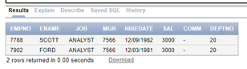

select max(sal) from emp where sal not in (select max(sal) from emp);

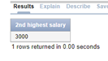

select empno,ename,sal from emp e where 2 > ( Select count(sal) from emp where e.sal < sal );

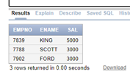

select distinct sal from emp e where 2 > ( Select count(sal) from emp where e.sal < sal );

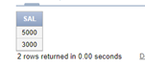

select distinct sal from emp e1 where 2 = (select count(distinct sal) from emp e2 where e1.sal >= e2.sal);

(or)

select min(sal) from emp where sal not in (select min(sal) from emp);

